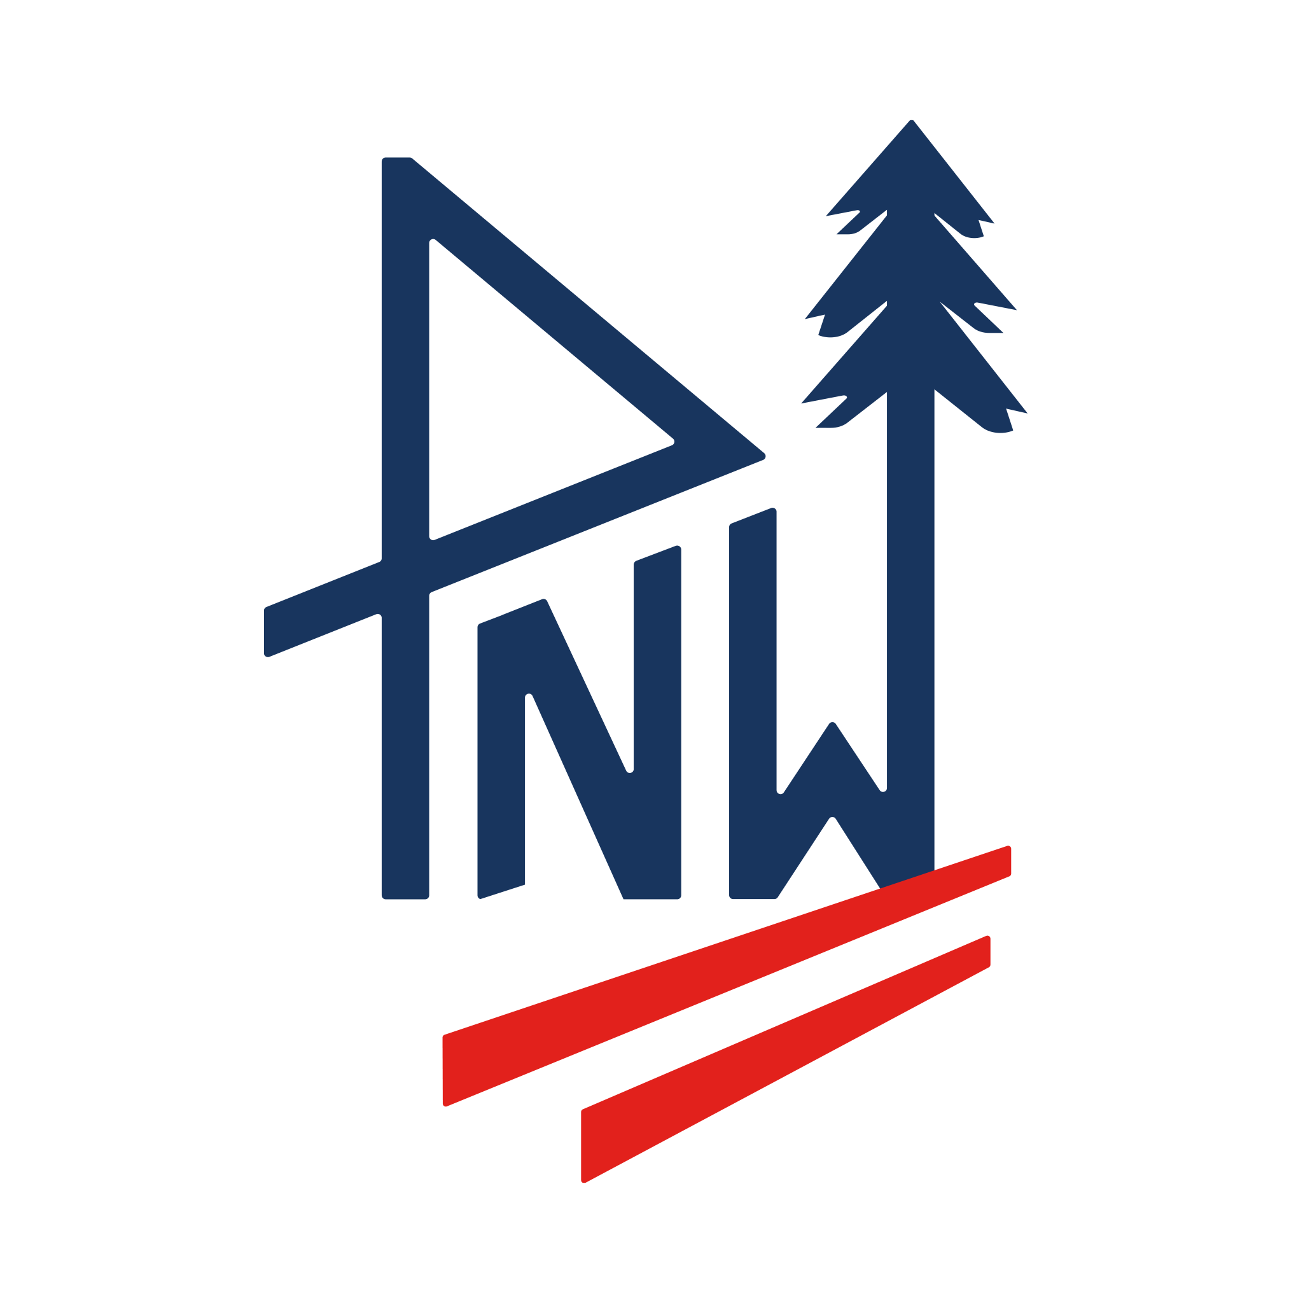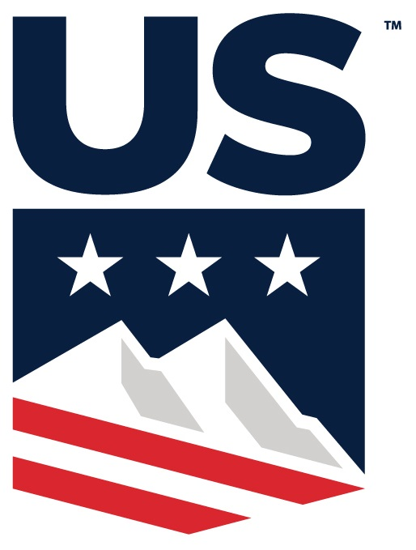

Pacific Northwest Ski Association
A Division of U.S. Ski & Snowboard

(DRAFT) Board of Directors – 2025 Fall Meeting
Thursday, November 5, 2025
6:30pm Virtual via Zoom

Karl Wardrop welcomed all members to the PNSA board of directors for term 2025 – 2026 Fall meeting of the 2025 – 2026 PNSA board of directors @ 6:34pm

Roll Call: The following officers and directors were present at roll call. Karl Wardrop, Tim Durkin, Molly Dennehy, Malcolm Ash, Justin Rackley, Colin Quinn-Hurst, Roger Root, Mark Stapleton, Jeff Kray, Reitler Hodgert, John Rust, Lily Eriksen, Karen Lundgren, Annie Elgee

Not present: Courtney Altringer

Claudia Yamamoto – PNW executive director

Gallery: Tracy Gibbons PNWSEF, Andrew Vetterlein PNWSEF, Pete Korfiatis PNSAA, Kirsten Huotte PSIA

A quorum was present per Article III Section 4 of the PNSA By-Laws.

2025 – 2026 PNW BOD Motion #7 To approve agenda as presented.
Maker: Jeff Kray, Second: John Rust Motion Passed

PNWSEF: Tracy Gibbons/Lily Eriksen – Annual auction went well and more funds were raised than we had in the past. Big thanks to Tracy and Kerry for leading the charge. We are coming up on our annual appeal, with a big push going into ski season. We are looking for 100% participation from both PNW and PNWSEF boards as well as ACC and NCC. Although it’s a busy fundraising time, please get the word out to all your clubs. Coaches funding: we want to offer support with funds available to get all coaches educated to minimum of 100 level. PNWSEF provides additional safety for clubs currently thru b-nets, impact testing, and reimbursment for coaches certification. We have approved reimbursing up to $250 for coaches interested in getting certified. One goal is to provide a link to PNWSEF on each club’s website so coaches can easily fill out paperwork to get access to these funds. Another reason for getting clubs to make a link on their sites to PNWSEF is to make it easier for fundraising and for team members, parents and coaches to get to know the foundation. We are also working to get concussion protocol links to club websites for parents/coaches to easily navigate the proper steps should their athlete become concussed. We are looking for input as to how to get the process in place on the PNWSEF site for coaches to request reimbursement. We want to make it as simple as possible, and get things rolling before the ski season starts.
Karen Lundgren volunteered to help Tracy set this in motion.
Pete Korfiatis mentioned it might be prudent to have a limited window for coach certification reimbursement after they are registered with their club to prevent reimbursing people that may leave and go to another division.

2025 – 2026 PNW BOD Motion #8: To approve minutes from June 1st Meeting
Maker: Molly Dennehy, Second: Karen Lundgren. Motion Passed

Financial Update: Malcolm Ash – We are hitting where we should be this year monetarily. Expenses are our normal run-rate expenses, although we have spent to budget on our b-net. We purchased early last year to beat potential tariffs, so we are ahead on b-net needs this year. Distributions went to Mission Ridge and will also be going to MBSEF. We’ll know more regarding income as we start seeing revenue from races. We are still making healthy money on interest income. We are still in the process of doing taxes for last year, and income is a little lower due to b-net expense. Financial Report will be available on website. Karl Wardrop added that training costs for officials are our first expenses for the fiscal year. There are many training and update clinics available in the coming weeks – register on website.

REPORTS:
Executive Director: Claudia Yamamoto – We’ve had quiet fall until about 2 weeks ago – now all kinds of things are happening as we get closer to our season. We have new rules in the officials roles that we are currently trying to clarify, as well as new motions for U16s that we’ll discuss later in the meeting. Elite pass sales are going really well – on par with last year, and we’re just waiting for snow. Membership is holding strong in our division, where it is not across the nation, so we are doing things right in retaining our older athletes.

President: Karl Wardrop – Officials training is going well, and we are getting the calendar finalized. We are looking good financially as we have reserves that will support us for 2 years. This allows us to move forward in a good position should we have a low snow year or a Covid-like situation affecting revenues.

Vice President: Tim Durkin – Nothing to report except that we are loving the little bit of snowfall so early and waiting for more!

Secretary: Molly Dennehy – Since I missed the summer convention, I want to welcome all the new board members.

Motions from the Alpine Competition Committee: Justin Rackley – the ACC met last week – things came up out of western region that we needed to address, but not anything major.
- Calendar – There is one calendar change that took place. Stevens Pass/Vail is unable to run the NWcup finals on the dates allotted, as it is beyond their scheduled closing date. At our fall meeting, Mission Ridge stepped up and was approved as the new host for the NW cup finals.

- New motions since Convention:
2025 – 2026 PNW BOD Motion #9: Proposal for PNW race organizers utilize the same slalom gate type (& height) being used at the U14 Regional Championships during each of the U14 PNW series events, so that we are in sync with the region level comps. (example: FIS type B 72”)
Maker: Justin Rackley, Second: Karen Lundgren None Opposed. Motion Passed

2025 – 2026 PNW BOD Revised Motion #10: Proposal to use remaining funds allocated to the PNW Alpine Team for entry fee compensation in the following form:
- Current U16 Alpine Team members will receive paid entry fees for up to 2 race starts at an Evergreen Cup race.
- Current U18 & older Alpine Team members will receive paid entry fees for up to 2 race starts at a NW Cup race.
- Entry fees to be tracked and paid by PNW Division
Discussion – Malcolm Ash suggested tracking the funds used for these entry fees, so we can make this a budget line item for next year.
Karen Lundgren – we need to clarify whether they have to race for 2 days or up to 2 days, and who is tracking and responsible for reimbursement. Claudia Yamamoto clarified that she will track and PNW will pay entry fees directly.
Malcolm Ash suggested that we change verbiage to state “up to 2 race starts” as opposed to “race days”.
Maker: Justin Rackley, Second: Tim Durkin None Opposed Revised Motion Passed

2025 – 2026 PNW BOD Motion #11: Proposal that PNW will select 10 women/10 men according to the Western Region determined quota for the Sean Nurse Memorial in Dec. at SnowKing, WY. Selection for these spots will be as follows:
- Any U16 athlete who qualified for the U16 Nationals in the previous season will be automatically selected.
- The remaining quota spots will be filled based on national points in GS and SL, using a single board with GS first and SL second.
Discussion: Claudia Yamamoto summarized that selection was based on last years’ U16 Nationals qualifiers and quota is filled via triple board from last year’s WR championships, WC pts. from Nationals championships, and World Cup pts. from Sean Nurse.
We are tackling this from our division to determine this methodology for selecting our 10 women/10 men. This motion is asking to approve this selection process.
Maker: Justin Rackley, Second: Mark Stapleton None Opposed. Motion Passed

Motions from the Nordic Competition Committee: Colin Quinn-Hurst –
- Calendar – no updates mentioned
- New motions since Convention
2025 – 2026 PNW BOD Motion #12: Proposal to approve for 2026 - the PNW Cup will be two weekends and non-JNQ races: Teacup and Kongsberger.
Maker: Colin Quinn-Hurst, Second: Justin Rackley None Opposed. Motion Passed
2025 – 2026 PNW BOD Motion #13: Proposal to approve that categories for the PNW Cup will be U14, U16, U18.
Maker: Colin Quinn-Hurst, Second: Justin Rackley None Opposed. Motion Passed

2025 – 2026 PNW BOD Motion #14: Proposal to approve all race distances published on PNW website for JNQ and PNW Cup for U16 and U18, for all races on the agenda, except Ozzbaldy 10k.
Maker: Colin Quinn-Hurst, Second: Karen Lundgren None Opposed, Motion Passed

2025 – 2026 PNW BOD Motion #15: Proposal to approve that all race day total distances will be equal to or less than the distances shown below:
- 3k-10k per day for U18-U20
- 3k-7.5k for U16 except for one 10k per season
- 3.5k and under for U14
- 2.5k and under for U12
- 1k or under sprint for U14
- 1.5k or so for U10 and under
Maker: Colin Quinn-Hurst, Second: Jeff Kray None Opposed, Motion Passed

2025 – 2026 PNW BOD Motion #16: Proposal to approve that PNW Cup will not score races that do not meet guidelines.
Maker: Colin Quinn-Hurst, Second: Justin Rackley None Opposed, Motion Passed

2025 – 2026 PNW BOD Revised Motion #17: Proposal to approve implementation of
-15C / 5F as the cutoff (+/- 2 degrees F) for racing in PNW region for JNQ and PNW Cup races.
Discussion: Lily Eriksen asked if there is clarity as to whether this cut-off is for the race start time, or warm-ups? At what time do the officials assess the cut-off parameters?
John Rust – Agreed that this is great as a guideline, to ensure the safety of athletes, but you might want to add a range to give you a little leeway to use best judgement of determining whether to run the race.
Pete Korfiatis – suggested maybe adding +/-2 degree range.
Colin Quinn-Hurst moved to amend the motion to change the verbiage to add “+/- 2 degrees F”
Maker: Colin Quinn-Hurst, Second: Reitler Hodgert None Opposed, Revised Motion Passed

Update on modernizing the PNW By-Laws: Karl Wardrop - Karl is in the process of updating the By-Laws to modernize and simplify them. Revisions will need to be voted on by the delegates at the annual spring meeting. Karl will be distributing them and would like board members to review things specific to their role on the board and give feedback. Karl welcomes input from any on the board for potential edits/changes. Karen Lundgren agreed to assist Karl in this process.

Old Business : none

New Business: none

Karl Wardrop –
- Next BOD meeting Wednesday, January 7th, 2026 6:30pm via Zoom
2025 – 2026 PNW BOD Motion #18: Motion to adjourn the meeting.
Maker: Jeff Kray Second: Karen Lundgren Motion Passed
Adjournment: meeting adjourned at 7:54pm

