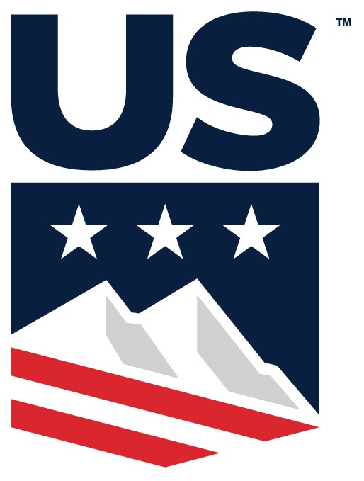

**Pacific Northwest Ski Association  
A Division of U.S. Ski & Snowboard**

**(DRAFT) Board of Directors – 2024 Fall Meeting**

**Thursday, November 7, 2024**

**7pm Virtual via Zoom**

Karl Wardrop welcomed all members to the PNSA board of directors for term 2024 – 2025 Fall meeting of the 2024 – 2025 PNSA board of directors @ 7:01pm

**Roll Call:** The following officers and directors were present at roll call. Karl Wardrop, Tim Durkin, Molly Dennehy, Malcolm Ash, Justin Rackley, Peter Leonard, Todd Grover, Rob Cravens, Annie Elgee, Courtney Altringer, Lily Ericksen

Not present: John Rust, Jeff Kray, Mike Burns, Karen Lundgren

Claudia Yamamoto – PNSA executive director

Gallery: Deanne Woodring PNWSEF, Kerry Godfrey PNWSEF, Aaron Ruddick

A quorum was present per Article III Section 4 of the PNSA By-Laws.

**2024 – 2025 PNW BOD Motion #7** To approve agenda as presented.

Maker: Molly Dennehy , Second: Tim Durkin **Motion Passed**

**2024 – 2025 PNW BOD Motion #8**: To approve minutes from June 2nd

Maker: Rob Cravens , second: Justin Rackley . **Motion Passed**

REPORTS:

**President: Karl Wardrop –** Financially we are in good shape. We have filed our 990 with the IRS. Calendars are in place for Alpine and Nordic so we look good there. We just started annual appeal for PNWSEF – please all BOD make a small donation so we have 100% participation. PNWSEF partners with PNW to support funding for education for coaches, safety equipment and scholarships for our athletes.

**Vice-President: Tim Durkin –** Stevens has a good looking start for the season and is opening up new terrain.

**Treasurer: Malcolm Ash –** Everything is tracking normal as in years past. Membership funds are up from what we’ve seen in the past mainly because of the dues increase. We’ve expended most of our B-Net budget as planned. Money market account holds most of our funds and we have interest income and credit card reward dollars totaling ~$9000. Balance sheet looks good. Claudia will post financials, so please feel free to contact Malcolm with any questions.

**Executive Director: Claudia Yamamoto –** membership is doing quite well – we raised dues and membership has not declined. Good sign for what our programs are doing at keeping members involved. Elite Pass sales are on track. New officials are very strong. 50 ppl attended Seattle clinic, and numbers are looking good for Portland and Coeur D’Alene.

**Alpine West: Dan Henry –** coaching staff in place and project selections are already happening for a December project

**PNWSEF: Kerry Godfrey –** Great strategic off-site meeting in September followed by the online auction, which was a success with many donations from the board. Starting our annual appeal which will run through Dec. 31st. Consistent communications twice a week which will include athlete and coach videos. Giving Tuesday is Dec. 3rd, so we want to spread the word and lead by example as a board. Communicate to community for 100% participation – any donation amount is appreciated. Kerry will send us links to forward to our clubs and parents/families. As we go into the next year we are looking forward to support and outreach to teams as we partner to bring safety equipment and scholarships to our coaches and athletes.

**Alpine: Justin Rackley –**

* **Calendar –** Everything in place. We had a few changes, which should enable U18 FIS kids to attend both WR events and NW Cups. Calendaring process actually went pretty smoothly with equity amongst the 3 zones. ACC has made good progress in this area to set intentional rules to evenly distribute the U14 qualifiers. We will continue to update as we get race announcements.
* **New motions since Convention:**

**2024 – 2025 PNW BOD Motion #9:** Proposal to approve ACC’s motion to suspend the PNW NWC 3 race start requirement for participation in WR U18-19 Championships.

Maker: Justin Rackley, None Opposed **Motion Passed**

**2024 – 2025 PNW BOD Motion #10**: Proposal to approve ACC’s motion for revisions to the ACC Structure By-Laws to add a section under ACC Exec committee for calendaring. It outlines the ACC Committee members/structure, providing equity of zonal distribution for calendaring. It also changes the acronym of PNSA to PNW throughout the document. The alignment of YSL Chair and BWC was also updated.

Maker: Justin Rackley, None Opposed. **Motion Passed**

**Nordic: Pete Leonard –**

* **Calendar –** Finalized and pretty much the same as what was presented in Spring. Have worked out the formats with all venues where races will be held. Lots of ideas being tossed around about flexibility around low snow season.
* **New motions since Convention**

**2024 – 2025 PNW BOD Motion #11:** Proposal to approve NCC’s motion to use 4 of 8 races for Jr. National qualification, with an athlete required to attend 4 race days to be eligible for selection to the Jr. National Team. In the event that they may not be able to hold 8 races, requirement is adjusted requiring athletes to attend a minimum of 50% of the races to be eligible for Jr. Nationals.

Maker: Pete Leonard, None opposed **Motion Passed**

**2024 – 2025 PNW BOD Motion #12:** Proposal to approve NCC’s motion to appoint representation into USSS XC Sport Committee and Coaches SubCommittees, naming Mike Burns, Reitler Hodgert and Pete Leonard to US Officials subcommittee,USSS Jr. subcommittee, and Coach Subcommittee respectively. This would also approve the agreement with the Far West division to alternate the Pacific representation so that each division always has one active representative on each committee.

Maker: Pete Leonard None Opposed, **Motion Passed**

**2024 – 2025 PNW BOD Motion #13:** Proposal to approve NCC’s motion to better utilize divisional wax supplies to support different divisions for different race conditions. Proposes $50/skier/race “head tax” to keep proper wax supply in the Jr. National Wax box.

Maker: Pete Leonard None Opposed, **Motion Passed**

**2024 – 2025 PNW BOD Motion #14:** Proposal to approve NCC’s motion to allow athletes to use their own uniform, while still continuing to search for used uniforms for skiers looking for one. Athlete will not be required to race in a PNW uniform at Jr. Nationals.

Maker: Pete Leonard None Opposed, **Motion Passed**

**Officials: Karl Wardrop -** Materials for training officials have been published. About 50 ppl attended Seattle training, with upcoming classes in Portland and Coeur D’Alene. Update classes on Zoom have also started, and will be offered multiple times throughout the season.

**Collegiate: Ron Bonneau/Rachel Urban –** Collegiate calendar is on PNW website. Collegiate Alpine and Nordic Champs will be at Bachelor and Ron Bonneau will be organizing.

**Old Business** : none

**New Business**:

**2024 – 2025 PNW BOD Motion #15**: Motion that PNW BOD directs the PNW Alpine Director to move the responsibility of PNW Project staff selection to the age appropriate working groups for the said projects (i.e.U12, U14, U16, U18(19), U21, Masters). PNW Alpine Director will retain oversight in said staff selection and project(s) delivery.

Maker: Tim Durkin , second: Rob Cravens . **Motion Passed**

**2024 – 2025 PNW BOD Motion #16**: Motion to approve PNW BOD proposal of dissolving the PNW ACC Coaches position and form a Task force to redefine the position’s scope, responsibilities and duties. The PNW ACC Alpine Director will chair this Task force, and a minimum of 3 PNW Board members will join this task force. A final draft regarding the task force’s findings will be presented to PNW BOD, and the potential new working group candidates selection will be approved by the PNW BOD. Target date for completion and selection of the new working group of 3 members and chairperson is 12/31/24, with selection attempting to include PNW zonal representation while focusing on skills, knowledge, and abilities.

Maker: Rob Cravens , second: Tim Durkin . **Motion Passed**

Discussion: USSS has redefined their education program. The idea is to focus on training for level 100 coaches and for the position to align with USSS’s program intentions. This task force would adjust the ACC bylaws, stating how Coaches subcommittee is tasked with staff selection for each PNW project, and is responsible to ensure that the rules/guidelines are followed. Subcommittee will host an annual education program for all coaches. *Anyone from the PNW Board interested in serving on this task force with Justin should reach out to him directly.*

**2024 – 2025 PNW BOD Motion #17**: Motion to approve the PNW Cell Phone Policy that would prohibit PNW project staff from removing cell phones from PNW Project Athletes. – Add: without written parental consent.

Discussion: What if a parent requests that the PNW staff take the cell phone from their Athlete? *Suggested to Add sentence* “without written parental consent”

Karl suggested to table until our next meeting, 1/7.

Maker: Malcolm Ash, second: Justin Rackley **Motion Tabled until next meeting with the above suggestion**

Karl Wardrop –

* Next BOD meeting January 7th, 2025 7pm via Zoom

**2024 – 2025 PNW BOD Motion #18:** Motion to adjourn the meeting.

Maker: Malcolm Ash , Second: Justin Rackley **Motion Passed**

**Adjournment: meeting adjourned at 8:40pm**